|  |
| --- |
| Circle Language Spec: Commands |

## Creation Behavior of Clauses in a Diagram

The creation behavior of clauses was already conceptually explained in the article *Creation Behavior of Clauses*. The current article demonstrates the concept using diagrams.

Just like other commands, that do not have a definition, a clause’s contents are created all the time, including its private contents.

Clauses being permanently created as long as the parent command is created even counts for clauses inside a command call. Right before a call is executed, its private contents are created, including the whole depth of its clauses.

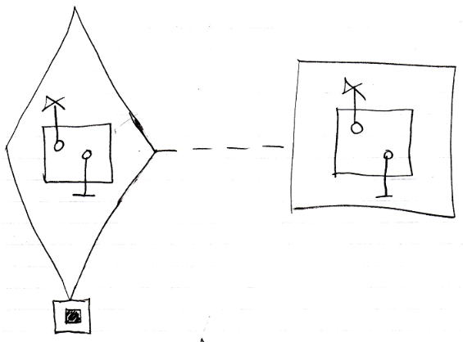

In theory the definition of the clause could be pointing to the clause inside the command call’s definition. The private contents of the clause could be created only just before the clause is run. But this is not done. As soon as a clause in a command call is copied from the definition, the clause has no connection anymore to the clause in the definition. Therefore, it needs to define its own private contents.

Even when the clause structure inside a command is very deep, the *whole* depth of the clause structure is recursively created when the parent command is created.

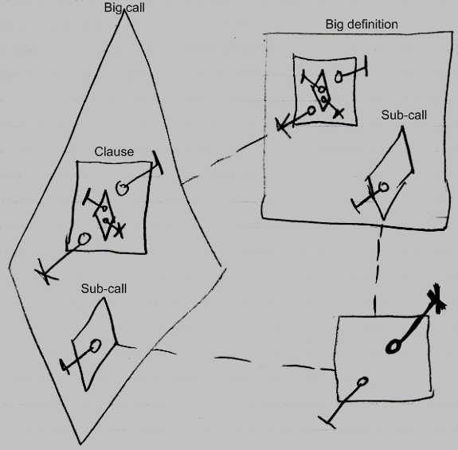

The sub-call inside the big call and inside the big definition only have the public parameter created, not their private contents as neither of them is running. But the clause, with all its contents, are created inside the big call all anyway.